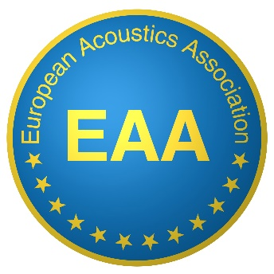
Serving 29 countries and more than 9 000 Members
EAA SUSTAINING MEMBERSHIP

to Companies, Institutions and Organisations,
As a sustaining member of the National activity of your Acoustical Society, now you can also support its European activities and involvements by becoming a
Sustaining Member of the EAA

The EAA is a non-profit organisation supporting the Acoustics in Europe by the possible means:
- 2 journals (Acta Acustica and Acoustics in Practice) and one newsletter (Nuntius Acusticus)
- 3 major conferences: Forum Acusticum, Euronoise and Euroregio
- Workshops
- Multi-lingual European repository (Documenta Acustica Electronica in progress)
- A Web-based University Guide (EAA Schola)
- 8 Technical Committees (more under formation process)
- European Job Forum (Forum Laboris)
- Young Acousticians Network (YAN)
The EAA actions are based on two principles: subsidiarity and solidarity.

As a Sustaining Member, you can choose one of the following options:
- Silver SM: 1 500 € / year
  - Logo displayed in Fenestra Acustica with a link to the Company website
  - Job announcements inserted in Fenestra Acustica
- Gold SM:3 000 € / year, Same as Silver + in addition
  - Logo displayed in EAA publications and in EAA Conferences
  - 5% discount on advertisement in EAA journals and exhibition in EAA conferences
- Platinum SM: 6 000 € and more / year, Same as gold +, in addition
  - Physical presence during specific actions like specific workshops, prizes, travel

For European Institutions, 25% of your contribution will be deduced from the dues of the National Society to the EAA and 75% will be used to support common EAA actions and European solidarity.
For non-European Institutions, all your contribution will support EAA actions and European solidarity.
Sustaining membership must comply with subsidiarity principle: unless otherwise stated by the National Society, a Sustaining Member supporting the EAA should first support and continue supporting the National Society.
EAA SUSTAINING MEMBER
APPLICATION FORM

Institution, Company, Organisation
- Name:
- Address:
- Country:
- Website:
Contact person:
- Name:
- Phone:
- Email:
Currently supporting (please specify National Society and dates):

Grade of Sustaining Member (please mark your choice):
- Silver: 1 500 € / year
- Gold: 3 000 € / year
- Platinum: 6 000 € and more / year

Declaration:
We are currently supporting our National Society and plan to continue supporting it in parallel with the EAA.

Name:

Signature:

Upon approval of your application by the board, an invoice will be sent with payment details.
Application must be sent by email to the EAA secretariat: secretary@euracoustics.org

Thank you for your trust in the European Acoustics Association.

